Annex 1
Rules of the 1st World
University Underwater Robot Competitions

Contents
Ⅰ.AUV Competition Rules 2
1.Description of the Competition 2
1.1 Venue & Site 2
1.2 Competition Requirements 3
2.Introduction to Competition Tasks 5
2.1 Passing the Qualification Gate 5
2.2 Hitting Floating Ball 7
2.3 Precise Work 9
2.4 Rising onto the Flotation Frame 12
3.Scoring Criteria 15

Ⅱ.ROV Competition Rules 17
1．Description of the Competition 17
1.1 ROV 17
1.2 Venue & Site 17
1.3 Competition Requirements 18
2.Competition Tasks 19
2.1 Delivery Feeds 19
2.2 Inspection of Hull 20
2.3 Collecting Ores 23
2.4 Precise Operation 24
3.Scoring Criteria 26

III.Rules of Prototype Track 28

- AUV Competition Rules
1.Description of the Competition
AUV (Autonomous Underwater Vehicle), one of the main categories of underwater vehicles, which integrates controllers, sensors, computer software and power, and it has autonomous perception and intelligent decision-making capabilities, and navigates with its own power. With the ability of autonomous navigation and sailing, it can conduct large-scale navigation and detection missions, and is often used in marine aerial surveying, target search and marine exploration.
The competition tests perception and intelligent control of the AUV (Autonomous Underwater Vehicle) by examining its completion of various underwater tasks. The tasks of competition include: passing the qualification gate, hitting floating ball, precise work and rising onto the flotation frame by tracing acoustics signals. Underwater navigation markers with Aruco will help and guide the AUV during the first 3 tasks; Aruco markers or a 37.5kHz acoustic beacon will guide the AUV in the final task.
  - Venue & Site
Site Size: length not less than 20m, width not less than 8m, depth from 1.3m to 2.8m.

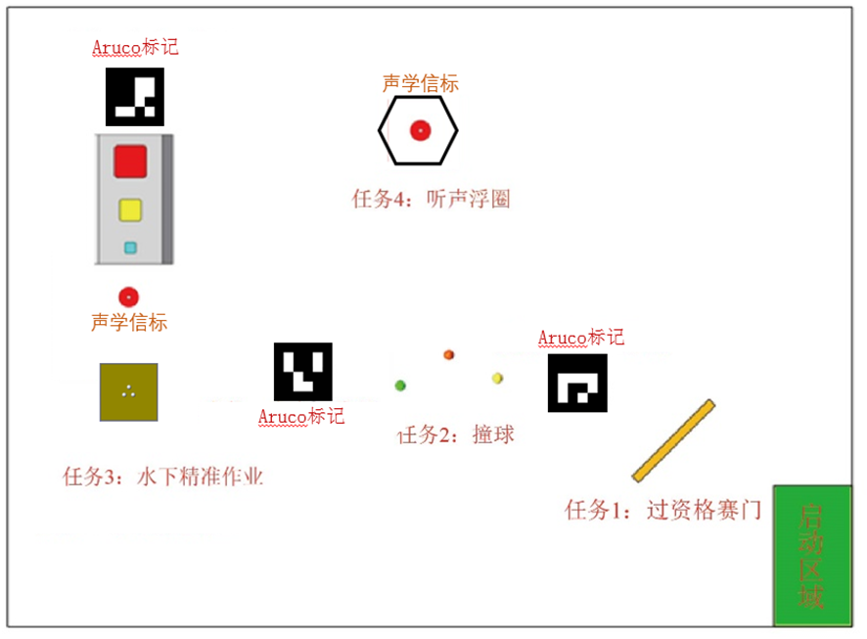
Figure 1 Competition Site Diagram

  - Competition Requirements
1.2.1Size and Weight
The weight of the vehicle shall not exceed 30 kg (weight in air). If the weight is below 30kg, corresponding bonus points will be applied; if the weight exceeds 30kg, points will be deducted for overweight. Vehicles weighing 45 kg or more are not allowed to compete.
The vehicle must fit into a cube size of 1000mm*1000mm*2000mm.
The team can use 2 vehicles if their total mass and dimensions do not exceed the specified limits.
1.2.2 Power Supply
The power supply can only be rechargeable battery, with the voltage not exceeding 72V. It is forbidden to use a 220V AC power supply.
1.2.3 Emergency Switch
Each vehicle must have a reliable security (emergency) switch to shut down the system and stop all propellers during an emergency. The switch should be placed in a prominent position on the surface of the vehicle, which can be easily operated by the diver in case of emergency.
1.2.4 Others
A. During the competition, except the balls for competition, no parts or accessories can be separated from the vehicle and nothing can be thrown into the pool. There should also be no leakage of oil or other pollution.
B. During the competition, once the AUV (or one of the AUVs) floats onto the surface, the attempt ends.
C. The AUVs must autonomously pass all tests. Teams are prohibited from touching the water in pool with any device or using any wireless device to remotely control the vehicles.
D. Total attempt time for each team is 30 minutes, 10 minutes for debugging and preparation and 20 minutes for the competition. The team announces the start of the competition and the referee starts the clock for 10 minutes The AUV should pass the gate within 10 minutes after the starting of the race. The attempt ends when the AUV floats.
E. If the participants consider that the result of the current attempt is unsatisfactory, it can be terminated at any time, then a second attempt may be made. When the team members announce the termination of the current attempt, the 20-minute timer will be suspended and the score of this attempt will be invalid. The robot will be salvaged by the staff, and the timer will continue when the robot is handed over to the team members.
F. A team member can be appointed to contact the judge, participate in the draw and stop the attempt, if necessary.
G. Only if all the four tasks have been completed with scores at the end of the competition, additional points can be awarded for the remaining time.
2.Introduction to Competition Tasks
2.1 Passing the Qualification Gate
2.1.1 Description
It is allowed to continue to complete the tasks only after the AUV has passed the qualification gate. Otherwise, points will not be counted for completing following tasks.
2.1.2 Props Description
The qualification gate is a rectangular frame made of orange PVC pipes, consisting of orange uprights and buoyant beams, the color of the gate is orange, with the frame of 2500mm × 1500mm, the specific dimensions are shown below:

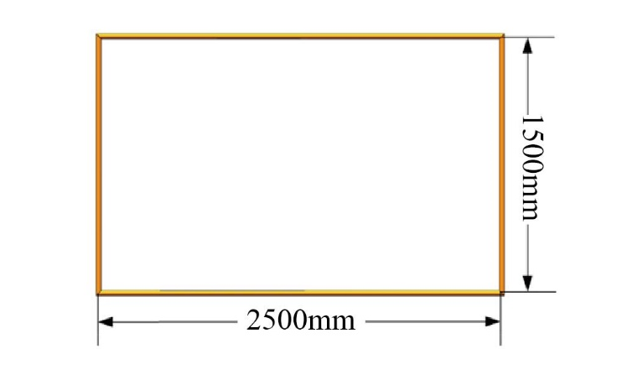

Figure 2 Qualification Gate
Behind the gate, there is a plate with a Aruco marker for the positioning and guiding (as shown below). All Aruco markers are different. The size of the plate is 400mmx400mm. The rotation angle (from -180 to 180 degrees) is encrypted in the Aruco markers to guide the AUV to the second task. Its position is shown in the figures below.

Figure 3 Aruco marker for Positioning and Guiding
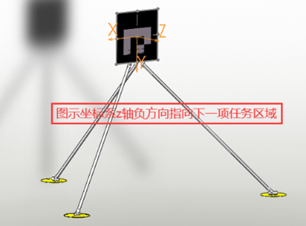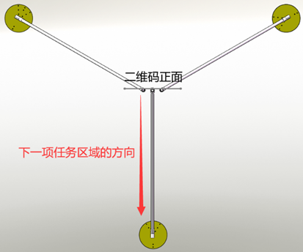
Figure 4 Placement and Position of Aruco Marker
2.1.3 Instruction of Rules
The AUV launches to dive in the starting area and begins to complete the tasks. The attempt will end when the vehicle floats to the surface of the water outside the starting area.
Here is the formula to calculate the score of passing the gate:scores = (base points + additional points) * difficulty coefficient. Passing the gate underwater, the vehicle can get both base points and qualification of attending the subsequent tasks of the game.
Chanllenge points of skilled passing are given for rotations along the yaw axis or the roll axis during the passing process. For horizontal rotation (Z axis) , every 90-degree rotation can be awarded 25 points, up to a maximum of 200 points, but reverse rotation will deduct points back. The vehicle can also roll along the X axis or Y axis when it passes the gate, every 90-degree rotation can be awarded 50 points, up to a maximum of 400 points, but reverse rotation will deduct points back.
More detailed rules for scoring can be found in Appendix 1.
2.2 Hitting Floating Ball
2.2.1 Description
In this task, the vehicle needs to hit the balls placed under water in the correct order that is determined by the draw.
If the order is not followed subsequently, the points will be reduced accordingly.
The Aruco marker behind the ball will guide the AUV to the next task, where the size of the Aruco marker is 40mm*40mm, and the guide angle is from -180 degrees to 180 degrees.
2.2.2 Props Description
Three floating balls of different colors will be placed in the pool, each tied to a line with the other end fixed to the bottom of the pool by a heavy object. The distance between the floating ball and the surface of water is 0.6m~1.2m, and the heights of the floating balls are different, as shown below:

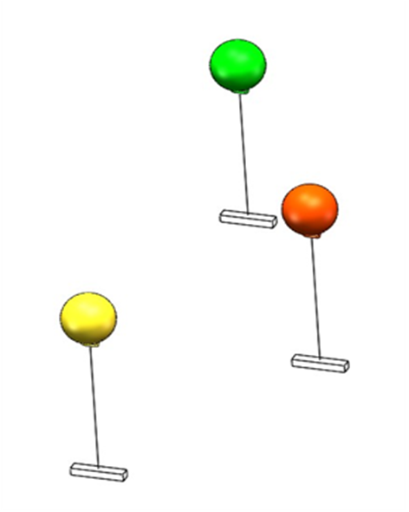
Figure5. Schematic Diagram of Floating Ball

3 standard inflatable floats with a diameter of 295 mm are used as floating balls. Balls with the help of a rope and a load, are installed in the water at different depths. The horizontal distance between the centers of the floats is about 2m.
2.2.3 Instruction of Rules
Before the starting of the competition, a draw is held to determine the order in which the balls to be touch. To get base points, the vehicle needs to touch the balls in any order. If the order is followed subsequently, then additional points are awarded.
The Aruco marker behind the floating balls will guide to the next task.
Figure 6 Aruco marker for Positioning of Underwater Precise Work
More detailed rules for scoring can be found at the end.
2.3 Precise Work
2.3.1 Description
The vehicle catches white balls from the display basket, and drops them into the basket cells. The smaller the cell is, the more points the vehicle can get. Besides one yellow golf ball carried by the vehicle, another 3 extra balls (white) can be caught from the display basket and cast into the basket cells. A plate with a Aruco marker is placed near the basket cells to guide the vehicle to the next task.
There will be an acoustic beacon near the basket cells, which will operate at a frequency of 30kHz.
2.3.2 Props Description
A display basket will be installed at the bottom of the pool. Negative buoyance exists in water. Three white balls are placed in the display basket. The dimensions are shown in the following figure:

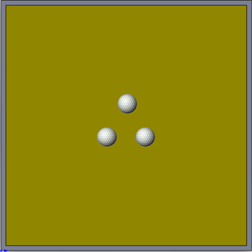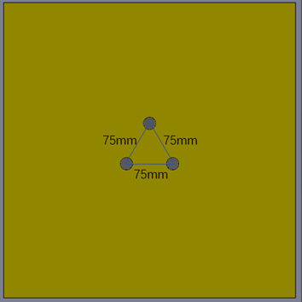
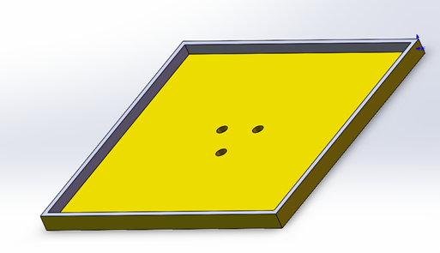
Figure 7 Underwater Golf Balls Display Basket
A storage basket with three cells of different sizes will also be installed next to the frame at the bottom. The vehicle needs to grab the golf balls from the display basket at the bottom and put it into basket cells, as shown below:

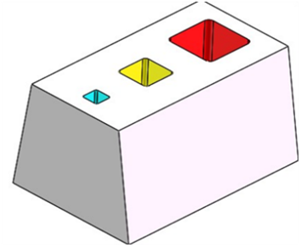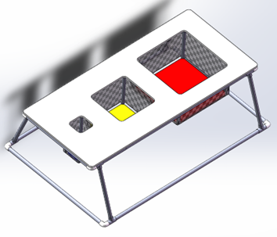
Figure 8 Storage Basket Cells

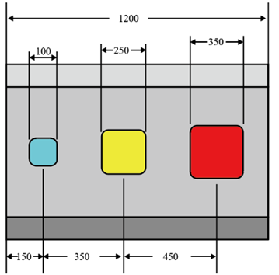
Figure 9 Schematic Diagram of the Storage Basket Size (mm)

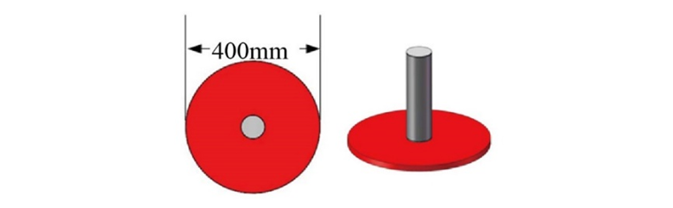
Figure 10 Underwater 30K Acoustic Beacon
The underwater precision operation area is equipped with 30k CW acoustic beacon to help the vehicle locate itself in the area.

Figure 11 Aruco marker for Underwater Precision Operation
A Aruco marker is also equipped in the area, specific Aruco marker needs to be further determined to be used to help the vehicle locate itself.
2.3.3 Instruction of Rules
The vehicle can get scores by casting balls in any cells of the basket. The smaller the cell is, the more points the vehicle can get.
2.4 Rising onto the Flotation Frame
2.4.1. Description
The vehicle needs to dive through the flotation frame at the destination guided by an acoustic beacon operating at a frequency of 37.5 kHz, and then rise onto the flotation frame to complete the task. The collar is fixed on the surface of the water and under the frame is an acoustic beacon operating at a frequency of 37.5 kHz set on a red plate. The plate itself can also be used for the location of the vehicle by light beacon.
2.4.2 Props Description

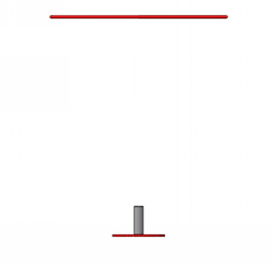
Figure 12 Schematic Diagram of Props for Rising through Floating Frame Guided by Acoustic Beacon

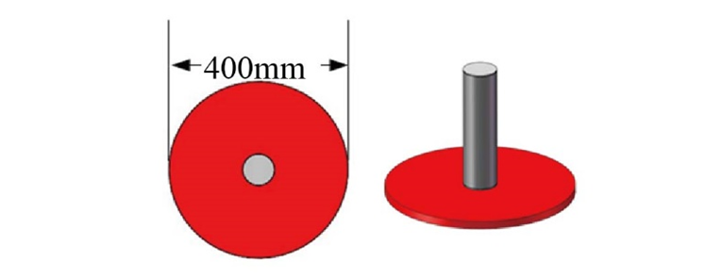
Figure 13 37.5k CW Signal Acoustic Beacon
A 37.5k CW signal acoustic beacon is arranged below the frame for the guidance of the vehicle. Meanwhile, there is a red plate at the bottom of the acoustic beacon that helps the vehicle locate itself. The diameter of red plate is 400mm.
The frame is an octagonmade of 8 PVC pipes with a length of 620mm.

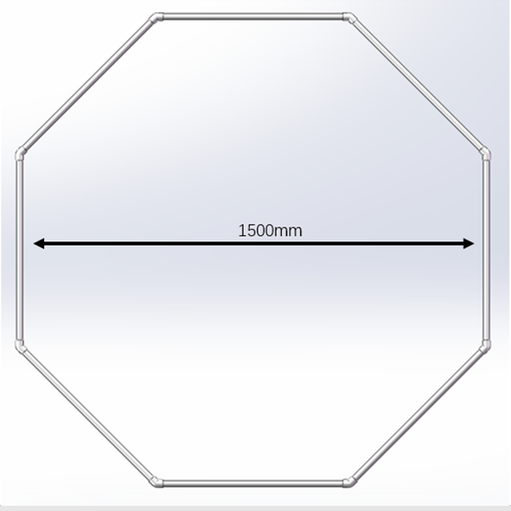
Figure 14 Schematic Diagram of the Floating Frame
((Since the 60° elbow is not easy to buy, it is changed to octagon)
)
2.4.3 Instruction of Rules
It is judged to be a successful floating if the vehicle rises to float out of the frame and stays for at least 3 seconds. The vehicle gets full scores if it does not touch the frame, otherwise penalty points will be given.
After completing all tasks, the AUV resurfaces outside the finish lap and simultaneously requests the end of the competition. The referee stops the clock and the rest of the time is converted into additional points for remaining time.

3.Scoring Criteria
The total score consists of work points completed within 20 minutes and the bonus points, in which the bonus points are awarded only if all the tasks are completed within 20 minutes. Grades are sorted by total score.
Tasks | Points | Max. point
Task 1: Passing through the Qualification Gate |  | 600points
Passing through the gate | 200 | 200
Passing through the gate with rotation: turning 90°×n in one direction | +25（50）*n | 400
Task 2: Hitting the Floating Balls |  | 700points
Hitting the Balls (for each) | +100 | 300
Hitting the Balls Subsequently of 1/2/3 ball(s) | +200/+400/+700 | 700
Task 3: Underwater Precise Work |  | 3300points
Casting the yellow ball into the large/medium/small cell of the basket | 200/400/600 | 600
Casting the white balls into the large/medium/small cell of the basket | 400/600/900 | 2700
Task 4: Rising onto the Flotation Frame |  | 1000points
Rising to float without touching | +1000 | 1000
Rising to float with touching | +500 | 500
Total |  | 275
Adding or subtracting points by weight of AUV | For each 1 kg less than 30 kg , +5 points;  For each 1 kg more than 30 kg ,– 5 points | -75  +75
Additional points for the remaining time of competition | Each 1 min +10 points,  No more than 200 points | 200
TOTAL |  | 5875

The attached schematic diagrams are for reference only, and the real props and facilities may be different.

The Competition Organizing Committee reserves the right of final interpretation.

- ROV Competition Rules
1. Description of the Competition
1.1ROV
Remote Operated Vehicle (ROV), also known asunmanned underwater vehicle, working under extreme circumstance of underwater, which can dive into the water to substitute human to complete the underwater operation. Owing to the harsh and dangerous underwater environment and human's diving depth limitation, underwater vehicle has served as an important tool for the ocean exploitation. The way it works is that the staff of the supported vessel provides power via connecting the ROV umbilical cable, operates or controls the ROV, observes through underwater monitor, sonar and other special equipments, and conducts underwater operations through the manipulator.
The Competition examines the underwater comprehensive operation ability of the ROV, including scouting the aquaculture area and feeding, inspecting the hull, collecting ores, and underwater precise operation of the seabed detection.
1.2 Venue & Site
Pool size: 10m×5m, depth from 1m-1.3m, as shown below:

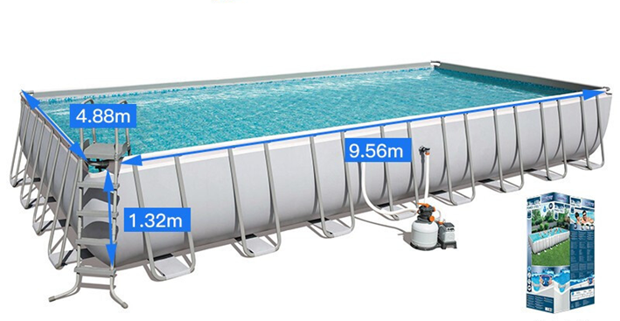
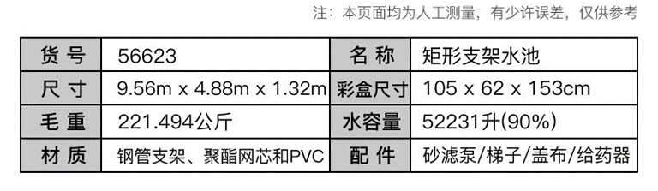
Figure 15 Site Diagram
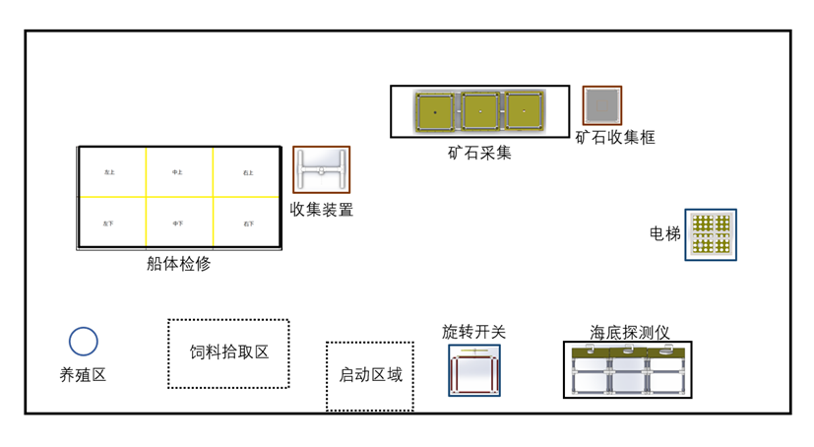
Figure 16 Schematic Diagram of the Layout of the Competition Site
1.3 Competition Requirements
A.Quantity: up to 1 (crawler walking is not allowed to avoid damaging the landform of the competition site)
B.The base weight of the vehicle is 20kg of net weight in the air(weight of umbilical cable is not calculated). If the weight is lower than 20kg, bonus points will be applied; if it exceeds 20kg, corresponding points will be deducted. The weight of the vehicle shall not exceed 25kg, otherwise it will not be allowed to participate in the competition.
C.Size: when the manipulator is retracted, the ROV shall be able to fit into a cube of 2000mm×1000mm×1000mm.
D.Number of Control Operators: no more than 2 persons.
E.Number of Umbilical Cable Operators: no more than 2 persons.
F.Time Limit: 10 minutes.
G.Control operators can not see the vehicle in the pool during operation.

2. Competition Tasks
2.1 Delivering feeds
There are aquaculture areas in the ocean ranch, where teams operate vehicles to cast feeds.
The feed container in the feed pick-up area is a 500ml plastic bottle, and the bottle is equipped with a counterweight, which exhibits a negative buoyancy of no more than 5N in water. Each feeding area is a cylindrical with a diameter of 125mm× height of 150mm, as shown in the figure.
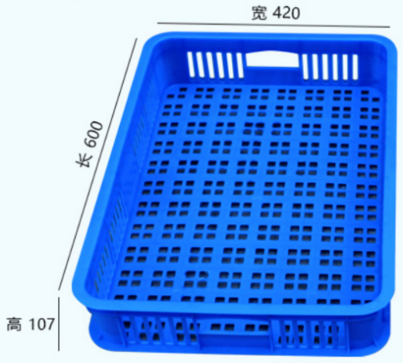
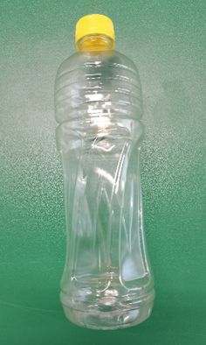
Figure 17 Diagram of Feed Container (without the counterweight, the bottle of Green Ice Tea)
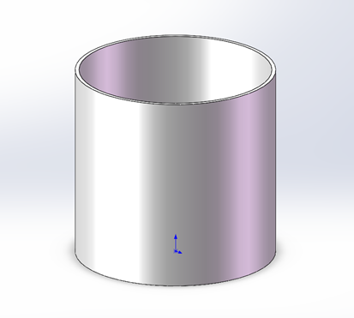
Figure 18 Diagram of Aquiculture Area
2.2 Inspection of Hull
Teams operate vehicles to inspect the underwater part of the hull, and clean up the damaged part of the hull.
2.2.1Inspecting the Hull and cleaning up the damaged part
The underwater part of the hull is a 1200mm×2400mm rectangle made of blue PVC pipes. The rectangle is divided into 6 areas by red PVC pipes with the diameter of 20mm. The areas are divided to be upper left, upper middle, upper right, lower left, lower middle and lower right. Each area is a rectangle of 600mm × 800mm. The schematic diagram of the hull is shown in the figure below.

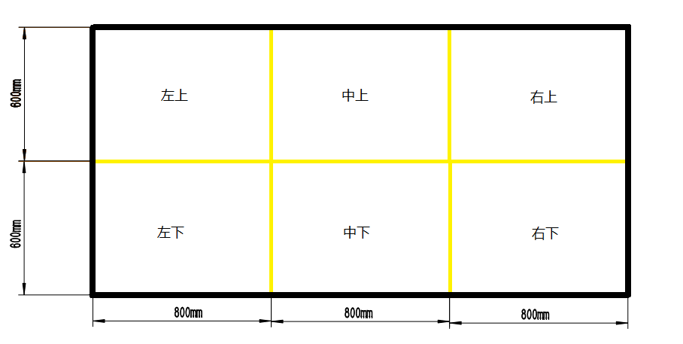
Figure 19 Diagram of the Hull
There will be 6 damaged parts on the surface of the hull, which are represented by red(blue) plastic rings(three red, three blue). There is one damaged part in each area and the corresponding colors are shown in the figure above. During the inspection, the vehicle picks up the damaged part and hangs it into collection device of the same color. At the end of the competition, points are scored according to the correct colored rings retained.
The plastic ring is made of pneumatic pipe and bolts, which has less negative buoyancy under the water and it is placed at the bottom of the pool. The collection device is made of pipes with the diameter of 50mm, as shown in the diagram.

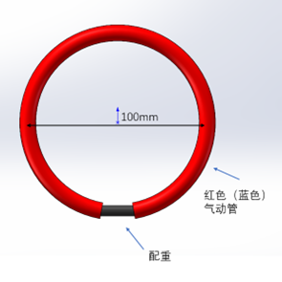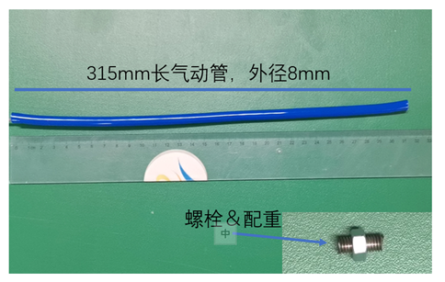
Figure 20 Diagram of Damaged Part(Plastic Ring)
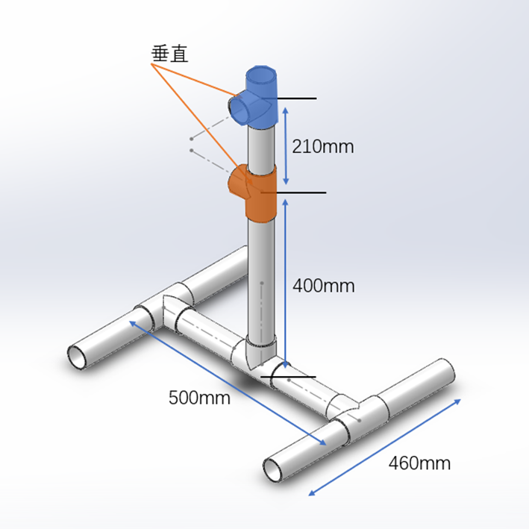
Figure 21 Diagram of the Collection Device

2.3 Collecting Ores
Different types of ores (golf) are distributed in reef gaps. Teams control the ROV to collect ores and drop them into the collection cells about 300mm-550mm away from the bottom of the water.

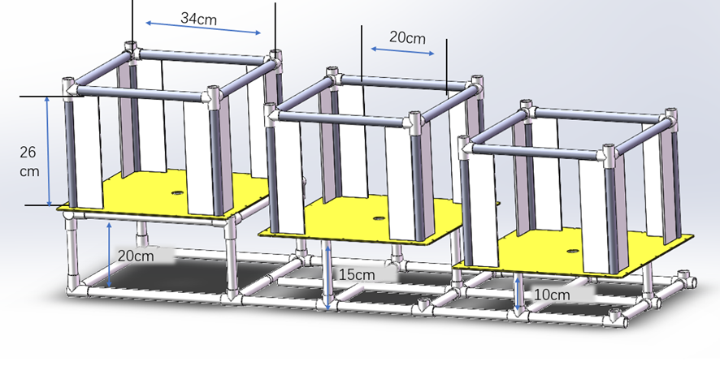
Figure 22 Diagram of Reef Gaps
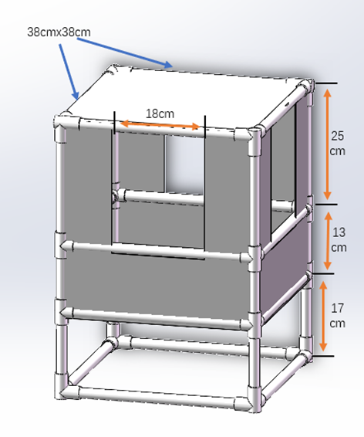
Figure 23 Diagram of the Collecting Cells
2.4 Precise Operation
The team operators control the ROV to remove the connector from the “elevator” first and then insert the connector into the seabed detector which is then started by the rotary switch. In this task, the interface of the seabed detector is set in three types: large, medium and small, and different types of interfaces are inserted to obtain different scores.
Specific tasks:
1.Obtaining the connector (T-plug with the length of 24cm and the width of 12cm) from the “elevator”
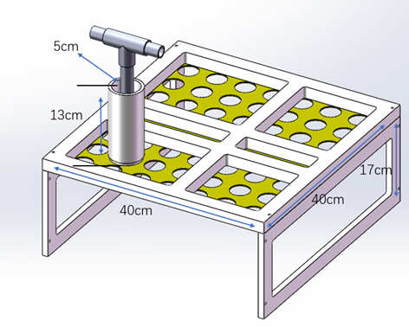
Figure 24 Diagram of the Elevator
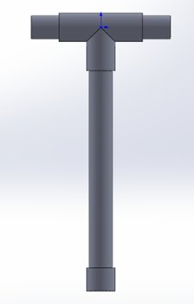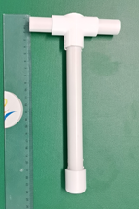
Figure 25 Diagram of the Connector(T-plug)

2.Inserting the connector into one of the interfaces of the seabed detector(Small - medium - large: 30mm-60mm-90mm)

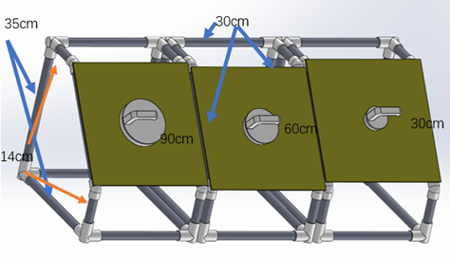
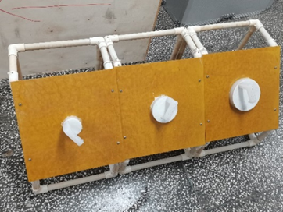
Figure 26 Seabed Detector Interface
3.Turning the rotary switch 180 degrees to start the seabed detector.

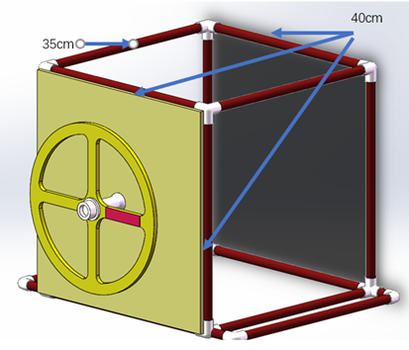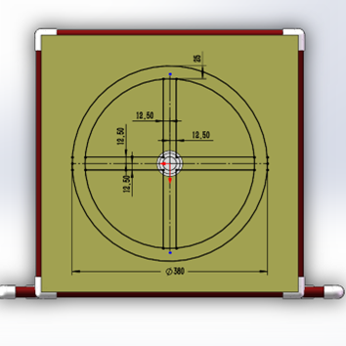
Figure 27 Rotary Switch
After completing all the tasks, the vehicle surfaces and the team claims the end of the competition. The referee stops the clock and the rest of the time is converted into additional points for remaining time.

3.Scoring Criteria
The total score consists of operation scores completed within 10 minutes and bonus points. Additional points for remaining time can only be scored if all tasks are completed within 10 minutes. Grades are ranked by total score.
Task | Score | Maximum
Task 1：Deliverying Feeds Delivery |  | 20points
Delivering feeds in the area | 20 points | 20
Task 2： Inspection of Hull |  | 65points
Correct Hanging at the end of the competition  One/two/three blue rings | +5 / +15/ +30 | 30
Correct Hanging at the end of the competition  One/two/three red rings | +5 / +15/ +30 | 30
Task 3： Collecting Ores |  | 45points
Placing ores in reef gaps into the collection box | +15 points /piece | 45
Task 4： Precise Operation |  | 30points
Grabbing and removing the plug from the "elevator" | +5 points | 5
Inserting plug into the interface | +5 points /10 points /15 points | 15
Turning switch more than 180 degrees | +10 points | 10
Others |  | 35
Weight bonus points and penalty points | 2 points deducted for each extra kilogram, with a maximum of 10 points; 2 points added for each insufficient kilogram, with a maximum of 10 points | -10  +10
Additional points for remaining time(round) | 1 point /10 seconds | 25
Total | 190

The attached schematic diagrams are for reference only, and the real props and facilities may be different.
The Competition Organizing Committee reserves the right of final interpretation.

III Rules of Prototype Track
1. Requirements
The Prototype Track is for an introduction and demonstration of the innovative design of underwater vehicles. The design shall be based on the operational tasks and technical requirements of the AUV/ROV track, and prototype design of the final assembly, parts, key techniques and other contents shall be carried out.
The entry design shall be innovative in functional theory and layout. The design instructions shall include main innovation points, calculation process, design drawings, implementation methods, and application analysis. The design instructions shall not exceed 25 pages (in addition, the technique introduction shall not mention the name and logo of the participating team, so as to facilitate the organization of online blind review in the later period).
Functional demonstration videos are encouraged to submit, which can be physical functional demonstrations or 3D model demonstrations. Two versions can be prepared for video production. The demo version shall not exceed 2 minutes in length and the file size shall not exceed 200M; the full version must not exceed 5 minutes in length and the file size must not exceed 1G.
Entries shall not mention any content involving national secrets, and the participating institutions are responsible for reviewing them.
2. Contest Rules
2.1 Contest process
Participating teams will conduct the draw to decide the defense order via webcasting. According to the team's defense and the design instruction, the experts will score to determine the contest results. The total defense should not exceed 10 minutes, of which the work description shall not exceed 5 minutes. Respondents must be members of the team and cannot be replaced by others outside the team.
2.2 Scoring Rules
The scoring rules are as follows:
Index item | Weights | Index connotation
Innovation and Uniqueness | 40% | The entry is innovative with novel structure and unique theory is, which is manifested in solving similar tasks with new methods, or solving tasks that have not been overcome.
Feasibility and practicality | 30% | The design is reasonable with clear implementation plan, possible task capabilities and characteristics, application prospects, and engineering feasibility.
Text content and | 20% | The text has strong logic, clear layers, clear points and clear argumentation, detailed theoretical analysis and experimental data.
Defense performance | 10% | The text is smooth and clear, the language delivery is concise and refined, the logic is strict, and the on-the-spot performance is good.

The Organizing Committee reserves the right of final interpretation.

